Write a secondary sort program to generate the top 2 maximum temperatures corresponding to every year from the temperature dataset.

DRIVER CLASS:

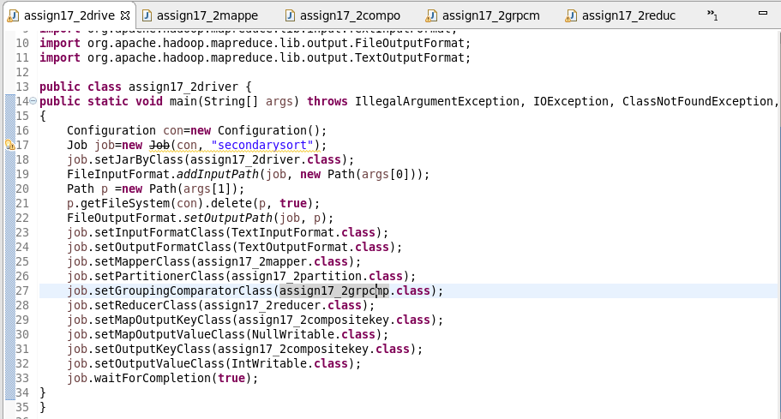

MAPPER CLASS:

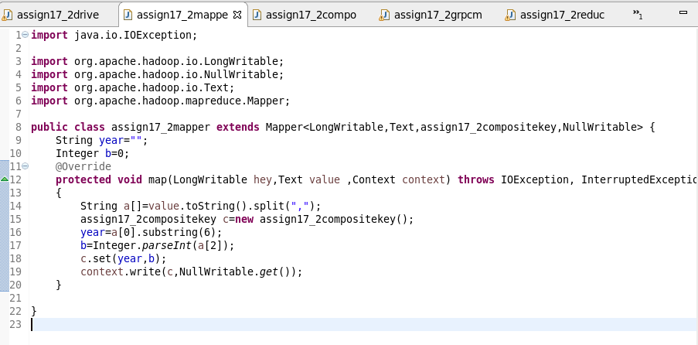

REDUCER CLASS:

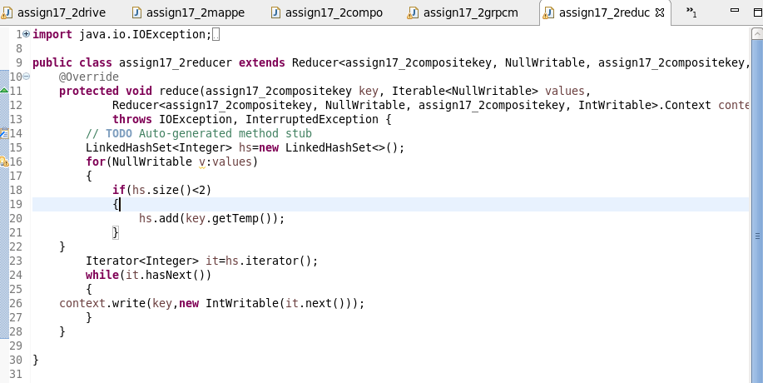

PARTITONER CLASS:

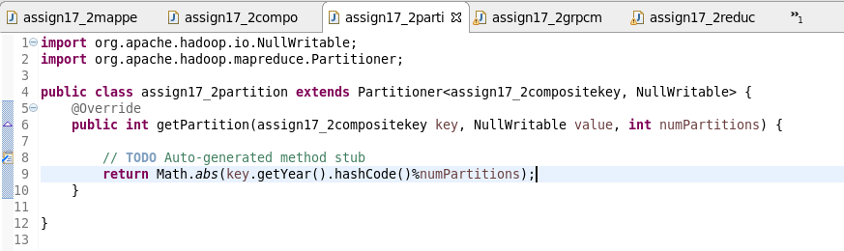

COMPOSITE KEY:

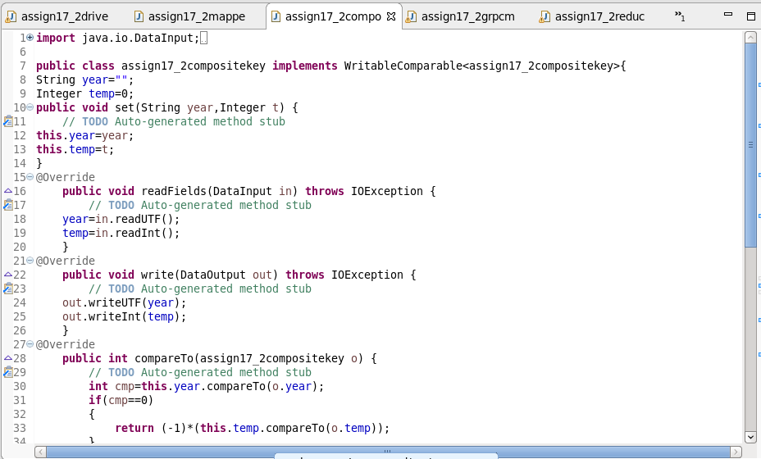

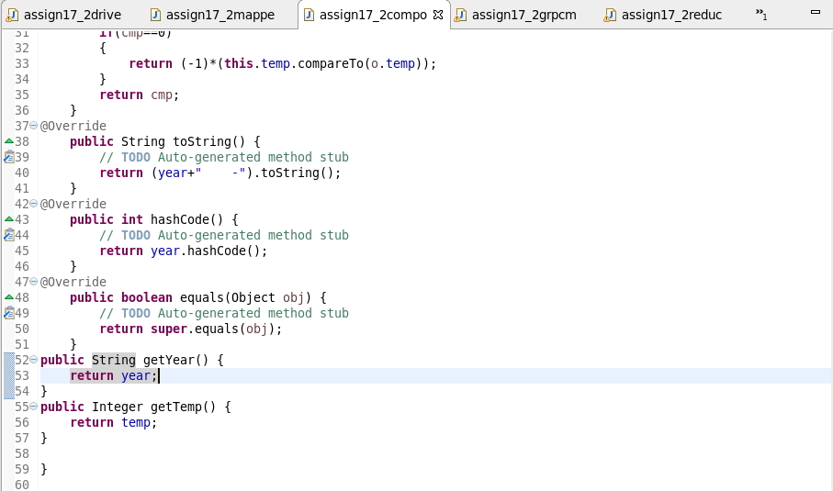

WRITABLE COMPARABLE:

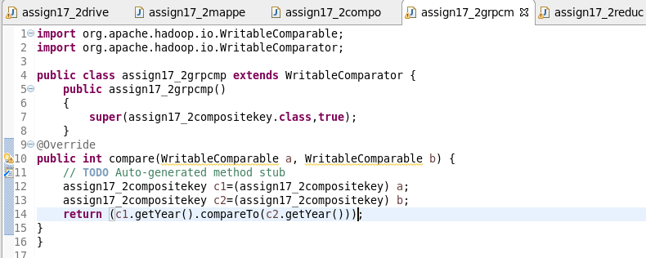

RUNNING JAR:



OUTPUT:

